Introduction
This report analyzes a dataset of 1 million+ loans to identify factors that lead to defaults. The analysis was performed using SQL for data preparation and Power BI for visualization.

ASK

Credit Portfolio Analysis - Business Questions

1. What is the Non-Performing Loan (NPL) Ratio?
- Question: What percentage of total disbursed loans are currently past due or in default ("bad debt")?
- Why it matters: This is the primary indicator of a bank's financial health and the quality of its credit assets.

2. How does the Credit Score (or Grade) impact the Probability of Default?
- Question: How much more frequently do customers with lower ratings (e.g., Grade E, F, G) stop paying compared to Class A customers?
- Why it matters: It validates whether the bank's internal risk assessment system (Credit Scoring) is accurate and reliable.

3. What is the relationship between Debt and Income (DTI)?
- Question: Is there a specific DTI threshold beyond which customers become excessively risky?
- Why it matters: This helps the bank establish strict regulatory limits and internal policies for the approval of new loans.

4. What is the purpose of the highest-risk loans?
- Question: Are "debt consolidation" loans riskier than "home improvement" loans?
- Why it matters: This data supports marketing strategies and risk-based pricing (setting interest rates based on the loan's purpose).

5. What is the geographic distribution of risk?
- Question: Are there specific geographic areas (states or cities) that show systematically higher insolvency rates?
- Why it matters: Essential for strategic portfolio management and for identifying regional economic crises or downturns.

Banking Glossary for Data Projects (Cheat Sheet)

1. Basic Loan Terms
- Principal: The original amount of money borrowed by the customer.
- Interest Rate: The percentage charged on the principal by the bank as the cost of borrowing.
- Installment: The fixed amount the customer pays every month.
- Term: The number of months scheduled for repayment (e.g., 36 or 60 months).

2. Loan Status
- Fully Paid: The loan has been repaid in full, including interest.
- Current: The customer is paying regularly and on schedule.
- Late / In Grace Period: A delay in payment (usually categorized between 16 and 120 days).
- Default / Charged-off: The loan is considered permanently unpaid; the bank has written it off as a loss.

3. Risk Indicators and Valuation
- Loan Grade: A bank's internal categorization of risk (e.g., A = low risk, G = high risk).
- Debt-to-Income Ratio (DTI): The percentage of a borrower's monthly income that goes toward paying debts. A higher DTI indicates higher risk.
- Annual Income: The yearly income reported by the borrower.
- Non-Performing Loan (NPL): Loans where collection is uncertain, typically after being overdue for more than 90 days.

4. Loan Purpose
- Debt Consolidation: Combining multiple high-interest debts into a single loan with a single monthly payment.
- Credit Card: Using the loan to pay off existing credit card balances.
- Home Improvement: Funding maintenance, repairs, or upgrades to a residence.

I DOWNLOADED THE CSV FILE FROM KAGGLE. I extracted it so it could be smaller andreadable in big query. Then i storaged on google cloud console and i created a bucket.

Data Cleaning & Preparation
- Data Selection: choose of the right columns (id, loan_amnt, int_rate, grade, addr_state, κτλ).
- The is_npl Logic:
  - Definition: Loans marked as "Charged Off" or "Late" were flagged as 1 (NPL), while "Fully Paid" and "Current" were flagged as 0.
- Date Formatting: changed the column issue_d to date

Create a binary flag using sql logic by organising npl as default loans, charged off or 30 or more days delay.

- i cleaned the data with what is only needed.

SELECT
id,
loan_amnt,
-- 36 mesi a 36
SAFE_CAST(REGEXP_EXTRACT(term, r'\d+') AS INT64) AS term_months,
int_rate,
installment,
grade,
emp_length,
home_ownership,
annual_inc,
verification_status,
issue_d,
loan_status,
purpose,
addr_state,
dti,
-- rossi mutui (NPL)
CASE
WHEN loan_status IN ('Charged Off', 'Default', 'Late (31-120 days)', 'Does not meet the credit policy. Status:Charged Off') THEN 1
ELSE 0
END AS is_npl
FROM
`civil-icon-433816-u2.banking_data.final_loan_analysis`
WHERE
id IS NOT NULL

Then I made some practice on sql but it will not have an impact on the results.
1:Purpose of npl ratio (Purpose);

SELECT
purpose,
COUNT(id) AS total_loans,
AVG(is_npl) AS npl_ratio
FROM
`civil-icon-433816-u2.banking_data.final_loan_analysis`
GROUP BY
purpose
ORDER BY
npl_ratio DESC;

2: Average credit score and interest?
SELECT
grade,
AVG(int_rate) AS avg_interest_rate,
AVG(is_npl) AS risk_level
FROM
`civil-icon-433816-u2.banking_data.final_loan_analysis`
GROUP BY
grade
ORDER BY
grade ASC;

3: (String Manipulation)
SELECT
term,
SAFE_CAST(REGEXP_EXTRACT(term, r'\d+') AS INT64) AS term_months
FROM
`civil-icon-433816-u2.banking_data.final_loan_analysis`
LIMIT 10;

Executive Summary
- Total NPL Ratio: 12.86%.
- Average Interest Rate: (Βάλε το μέσο επιτόκιο που σου βγάζει η κάρτα σου στο Power BI).
- Loan Volume: Πόσα δάνεια αναλύθηκαν συνολικά.

Key Visualizations & Analysis
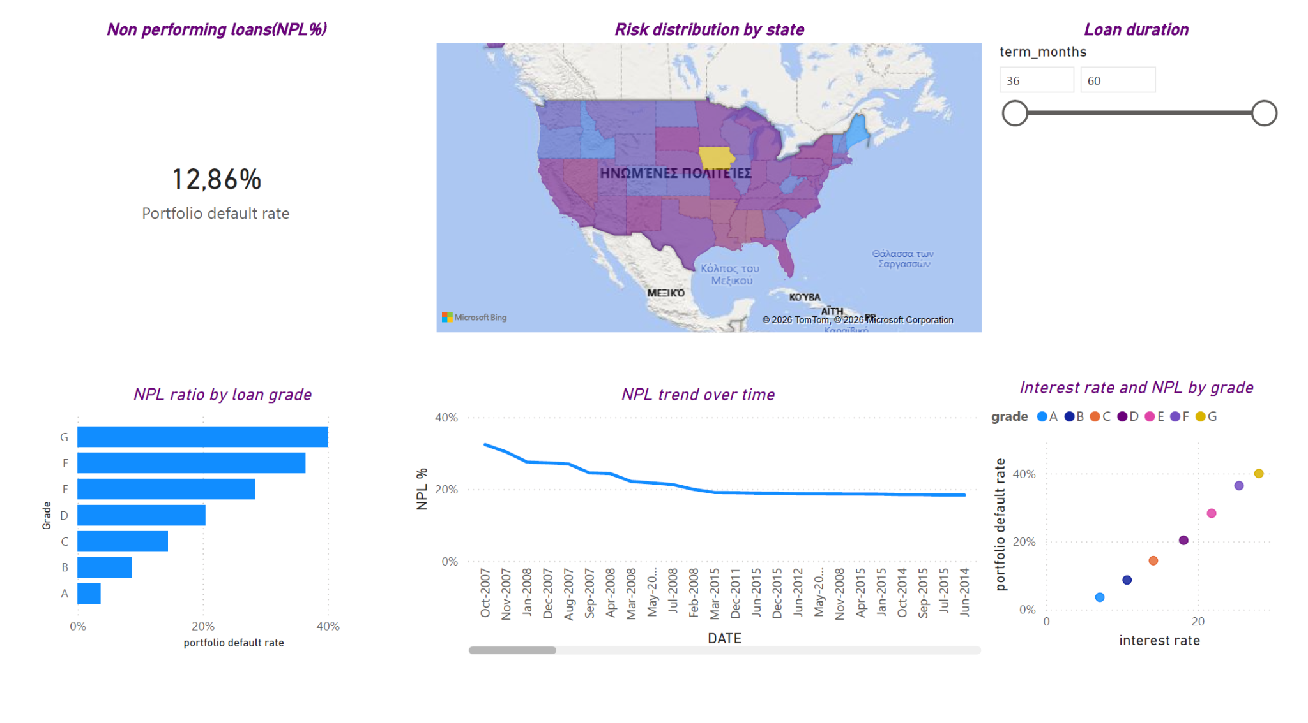
- Risk by Grade: "As expected, lower grades (E, F, G) show a much higher NPL ratio, reaching up to X%."
- Interest Rate vs NPL: "There is a clear positive correlation. The bank charges more for higher risk, which is a correct pricing strategy."
- Geographic Insights: "States like California and Texas show the highest volume, while [βάλε μια πολιτεία με υψηλό ρίσκο] shows the highest default rate."

Conclusion & Recommendations
- Review the 60-month loan product due to higher default rates.
- Implement stricter criteria for Grade G loans.

